**Report – Stefano Deriu - 2078244**

**compute_path_cost()**

In the compute_path_cost() function I’ve simply followed the equation from the Semi-global matching paper provided in moodle.

$$L_{r}(p,d) = C(p,d) + min(L_{r}(p-r,d), L_{r}(p-r,d-1) + P1, L_{r}(p-r,d+1) + P1, min_{i}(L_{r}(p-r,i)) + P2) - min_{k}(L_{r}(p-r,k))$$

In particular for the case in which a pixel is located at the border of the image I’ve considered the the smoothness term to be less reliable so that the path_cost is equal to the Data term C(p,d).

In all the other cases, I’ve calculated prev_cost as the path_cost of the previous pixel along the path direction for all possible disparities.  
The small_penalty_cost as the path_cost taken for the d+1 and d-1 disparities + p1_ of the previous pixel along the path direction.  
And the big_penalty_cost as the minimum of the path_costs of the previous pixel along the path direction + p2_.

Then considered only the minimum of these costs and calculated the entire formula.

**aggregation()**

The initialization of the variables follows the values for dir_x and dir_y. For example:

dir_x = 1, dir_y = -1

start_x = 0, end_x = width_ - 1, step_x = dir_x

start_y = height_ -1 , end_y = 0 , step_y = dir_y

**compute_disparity()**

Here I’ve created a struct to store the vectors for the high confidence disparities and initial guesses

struct DisparityPair

{ int d_mono;

int d_sgm; }

Then through the use of the Eigen library I’ve initialized the matrix A and the vectors b and x.

With the use of .transpose() and inverse() functions I’ve implemented $x={\left(A^{T}A\right)}^{-1}A^{T}b$, found h and k from it and then replaced every low confidence disparity with the respective $h*d_{mono}+k$ scaled initial guess.

**Quantitative results:**

**Aloe**:

MSE with only SGM: 122.464

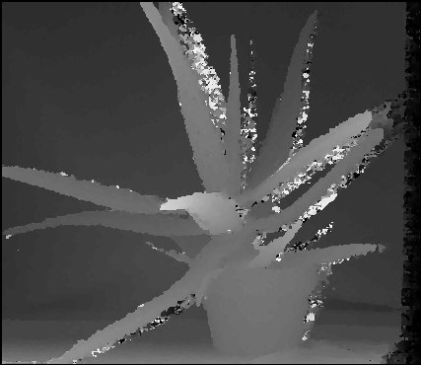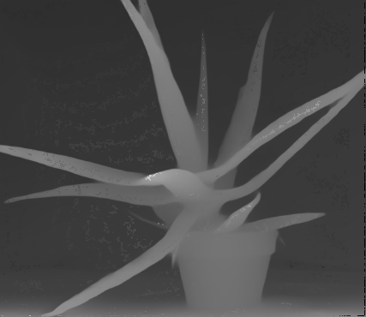MSE after refinements: 13.7291

**Cones**:

MSE with only SGM: 475.166

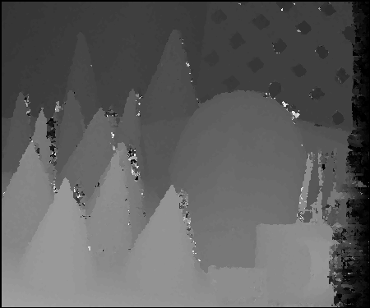MSE after refinements: 17.4342

**Plastic**:

MSE with only SGM: 820.049

MSE after refinements: 348.223

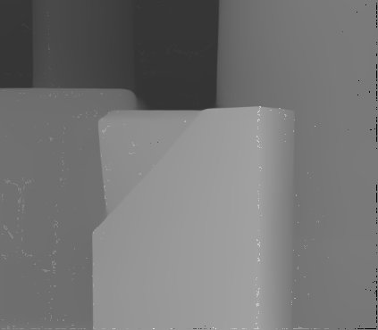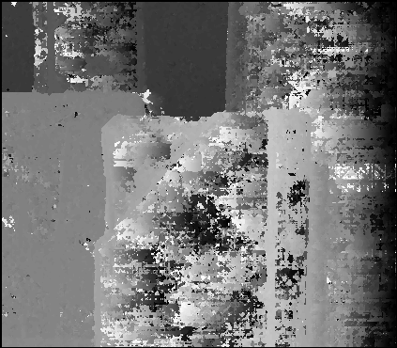

**Rocks**:

MSE with only SGM: 557.735

MSE after refinements: 34.6984

